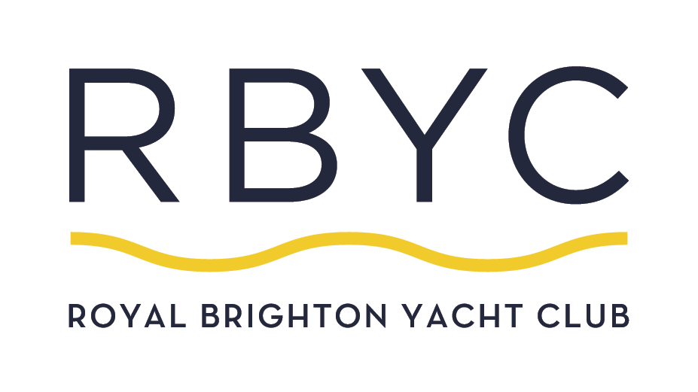

Small Plates

Oysters Natural (GF)
(3) $12
(6) $24

Oysters with Mandarin G&T (GF)
(3) $13.50
(6) 27

Salt & Pepper Calamari (GF) $24
Lemon & aioli

Leek & Mushroom Croquette (V) $18

Seared Tuna (GF) $22
with Japanese Ponzu sauce & seaweed salad

Ancient Grain Salad $19 (V)
legumes, roast pumpkin, avocado, coriander, hummus, pomegranate, dukka.
Add Chicken $5

Caesar Salad $19 (V/ GF)
with Green Goddess dressing.
Add Chicken $5

Lunch & Dinner Menu

Main Meals
Beer Battered Rockling Fillets $32
served with chips & salad.

RBYC Steak Sandwich $30
minute steak, bacon, cheese, tomato, lettuce, pickles served in focaccia with chips & salad.

Pork Cotoletta $36
delicious, crumbed pork medallion served with
Kohlrabi Remoulade & Parmesan

Linguini al Sugo Tonnato $32
served with clams.

Semolina Gnocchi $30 (V)
sundried tomato pesto, peas & spinach.
(Vegan option available upon request)

Whole Baked Flounder $36
with Lemon Butter served with herb salad & fries

Chargrilled Sirloin $45
cooked to your liking with cauliflower puree, bitter leaves.
and your choice of red wine jus, wild mushroom jus or peppercorn sauce.

Pizzas
Prosciutto & Buffalo Mozzarella $24.50

Margherita (V) $21

Side Dishes

Fries (V/GF) $12
with aioli & tomato sauce

Potato Wedges (V) $14
with sour cream & sweet chilli

Mixed Leaves Salad (VEGA/GF) $11

For The Little Ones
Suitable for children aged 12 years & under.

Margherita Pizza $10

Cheeseburger & chips $10

Chicken Nuggets & chips $10

Fish & chips $10

